**Anime Image Generation Using**

**Generative Adversarial Network**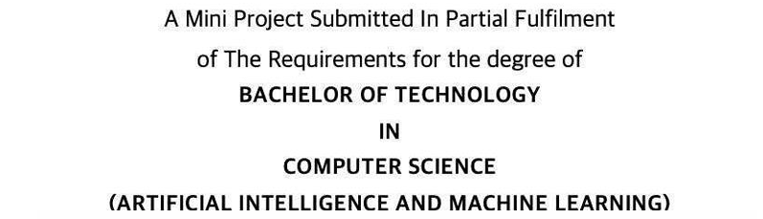

Kartik Khandelwal (063)

Pawan Kumar (092)

Rishabh Dev Parashar(108)

Tarun Kumar Singh (141)

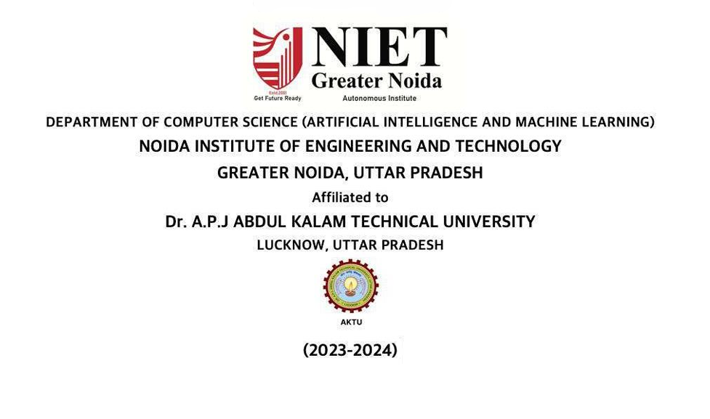

**DECLARATION**

We hereby declare that this submission is our own project and that, to the best of our own knowledge and belief, it contains no material previously published by another person nor material which, to a substantial extent, has been accepted for the award of any other degree or diploma of the university or other institute of higher learning except where due acknowledgment has been made in the text.

Kartik Khandelwal (063)

Pawan Kumar (092)

Rishabh Dev Parashar(108)

Tarun Kumar Singh (141)

**Signature of Candida**

**Acknowledgement**

Successfully completing any task gives us satisfaction and internal strength for future problems, but the person alone has never existed. A few people truly accompany him. They used to give the person support and suggestions to complete the work successfully. So, We feel pleasure thanking all such great people who motivated us and provided us with kind support at all stages of my Internship Project work.

Firstly, We would like to honor our institute, *“****Noida Institute of Engineering & Technology, Greater Noida****”.* Here, We have been provided with a workplace and infrastructure to learn recent technologies and conceptual background to strengthen our programming and professional skills.

We are very much grateful to **Ms. Oshin Misra, Assistant Professor (Computer Science and Engineering Artificial Intelligence & Machine Learning), and *Dr.* Mohammad Shahid *(Professor & Head,* Computer Science and Engineering Artificial Intelligence & Machine Learning*), Noida Institute of Engineering & Technology, Greater Noida*,** for his helpful attitude and encouragement in making my project.

Furthermore, We are thankful to all faculty members for motivating me and to the Staff ***of Computer Labs*** in the department for providing excellent valuable facilities, issuing us computer systems of good configuration, and providing regular maintenance.

We thank all our batch mates for their love, encouragement, and constant support.

Last but not least, We would like to thank our parents for supporting us to complete our project report in all ways

Kartik Khandelwal (063)

Pawan Kumar (092)

Rishabh Dev Parashar(108)

Tarun Kumar Singh (141)

**Abstract**

This detailed project report explores the application of Generative Adversarial Networks (GANs) for the generation of high-quality anime images. By focusing on the artistic stylization prevalent in anime, this project investigates the adaptability of GANs to capture and replicate the unique aesthetics of anime artwork. Through systematic experimentation and optimization, our project highlights the potential of this technology in the realms of digital entertainment, specifically in animation and gaming industries. The outcomes show promising directions for the use of advanced AI in creative industries.

#### **TABLE OF CONTENT**

**Title Page No**

**Contents**

**DECLARATION 2**

**Acknowledgement 3**

**ABSTRACT 4**

**Content Table 5**

**LIST OF TABLES AND FIGURES 6**

**CHAPTER 1 INTRODUCTION 7**

**CHAPTER 2 LITERATURE REVIEW 9**

**CHAPTER 3 METHODOLOGY 11**

**CHAPTER 4 IMPLEMENTATION 13**

**CHAPTER 5 RESULT 17**

**CHAPTER 6 TEAM CONTRIBUTION AND CHALLENGES 19**

**CHAPTER 7 CONCLUSION 21**

**REFERENCES 23**

**List of Figures and Tables**

Figure 1: Architecture of the basic GAN model

Figure 2. Architecture of the StyleGAN model

Figure 3: Input image(training images)

Table 1: Training configurations

Figure 4: Generator loss and Discriminator loss

Figure 5: Fake images generated by Generator

Figure 6: Model generated images

Figure 7. FID(Fréchet Inception Distance) score

**CHAPTER 1**

**INTRODUCTION**

**Background Information:**

Generative Adversarial Networks (GANs) have revolutionized the field of artificial intelligence by enabling the generation of realistic images from textual or noise inputs. In particular, their application in generating anime images has seen significant interest due to the growing popularity of anime worldwide.

Anime, with its vibrant characters and imaginative worlds, has captivated audiences worldwide for decades. The unique art style of anime, characterized by colorful visuals, exaggerated features, and expressive emotions, has become an integral part of popular culture. As technology continues to advance, one exciting area of exploration is the use of artificial intelligence (AI) to generate anime images.

In this project, we delve into the fascinating realm of anime image generation using Generative Adversarial Networks (GANs). But wait, what are GANs? Simply put, GANs are a type of AI model that learns to generate new data by learning from existing examples. Imagine having a magic paintbrush that can create new anime characters based on the ones you've seen before – that's what GANs do, but in the digital world!

Why is this important? Well, creating anime artwork can be time-consuming and labor-intensive for artists. By harnessing the power of GANs, we can potentially automate this process, making it faster and more accessible to everyone. Plus, GANs can produce an endless variety of anime-style images, allowing for creativity to flourish.

So, get ready to embark on a journey into the world of anime image generation with GANs. Who knows? By the end of this project, you might just discover your own favorite anime character brought to life by the power of AI!

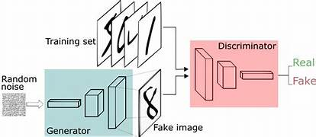

Figure 1: Architecture of the basic GAN model

**Project Objective:**

To develop a GAN that can generate diverse and appealing anime images, and to explore the technology's commercial applications.

**Scope of the Project:**

The scope is limited to the generation of face images of anime characters. The project does not cover full-body image generation or animation.

**In this project**, we'll explore how GANs work and how we can train them to generate anime images that are not only visually appealing but also capture the essence of the art form. We'll dive into the technical details, uncovering the secrets behind the magic of AI-generated anim

**CHAPTER 2**

**LITERATURE REVIEW**

Anime characters play a significant role in various forms of media, from books to video games. Recent advancements in Artificial Intelligence, particularly Generative Adversarial Networks (GANs), have revolutionized anime face generation. This literature review delves into the key findings and methodologies of several studies focusing on anime face generation using GANs.

**Deep Convolutional Generative Adversarial Network (DCGAN) vs. Style Generative Adversarial Network2**

**Anjana M S and Dr. Dhanya N M** compared DCGAN and StyleGAN2 for anime face generation, highlighting the superior quality of images produced by StyleGAN2 with a lower Fréchet Inception Distance (FID) score

The study concluded that while DCGANs guarantee results, the quality of images may be compromised, whereas StyleGAN2 excelled in generating globally convincing images with controlled features

**Automatic Generation of Facial Images of Anime Characters**

**Yanghua Jin and Jiakai Zhang** explored training GAN models specialized in anime facial image datasets, emphasizing the importance of clean datasets and proper training strategies to achieve stable and high-quality models

Their work led to the successful creation of a model capable of generating realistic facial images of anime characters, with a focus on assisting both amateurs and professionals in character design

**Full-Body Standing Figures of Anime Characters and Style Transfer by GAN**

**Hiroto Honda and Yusuke Uchida** discussed the generation of full-body illustrations of anime characters using GANs, particularly StyleGAN, showcasing the ability to generate high-quality standing pictures with specific resolutions and FID scores

The study highlighted StyleGAN's effectiveness in separating and transforming anime character features, enabling feature mixing and transformation through latent code interpolation

**Progressive Structure-conditional Generative Adversarial Networks (PSGAN)**

**Koichi Hamada and Kentaro** proposed PSGAN for generating full-body and high-resolution anime character images based on structural information, demonstrating the method's ability to generate detailed images for structured objects like full-body characters

PSGAN progressively increases image resolution and structural conditions during training, allowing for controllable animations with target pose sequences

**Conclusion**

The literature reviewed showcases the evolution of anime face generation through GANs, emphasizing the importance of clean datasets, proper training strategies, and advanced GAN architectures like StyleGAN and PSGAN. These studies collectively contribute to the advancement of anime character design and creation, offering insights into generating high-quality, realistic, and controllable anime characters through innovative AI techniques

**CHAPTER 3**

**METHODOLOGY**

**1.Data Collection:**

To start, we needed a bunch of anime faces to teach our AI how to make more. So, we gathered a dataset of 10,000 anime faces from all over the internet. We made sure to collect a wide variety of faces to cover different styles, expressions, and colors. This way, our AI could learn from a diverse set of examples.

**2.Model Description:**

Next, we needed a smart brain for our AI to learn from. We chose a special type of AI called StyleGAN2. It's like the artist's toolbox that helps our AI understand how to create realistic anime faces. We tweaked it a bit to make it better at generating high-quality images, like those you'd see in your favorite anime shows.

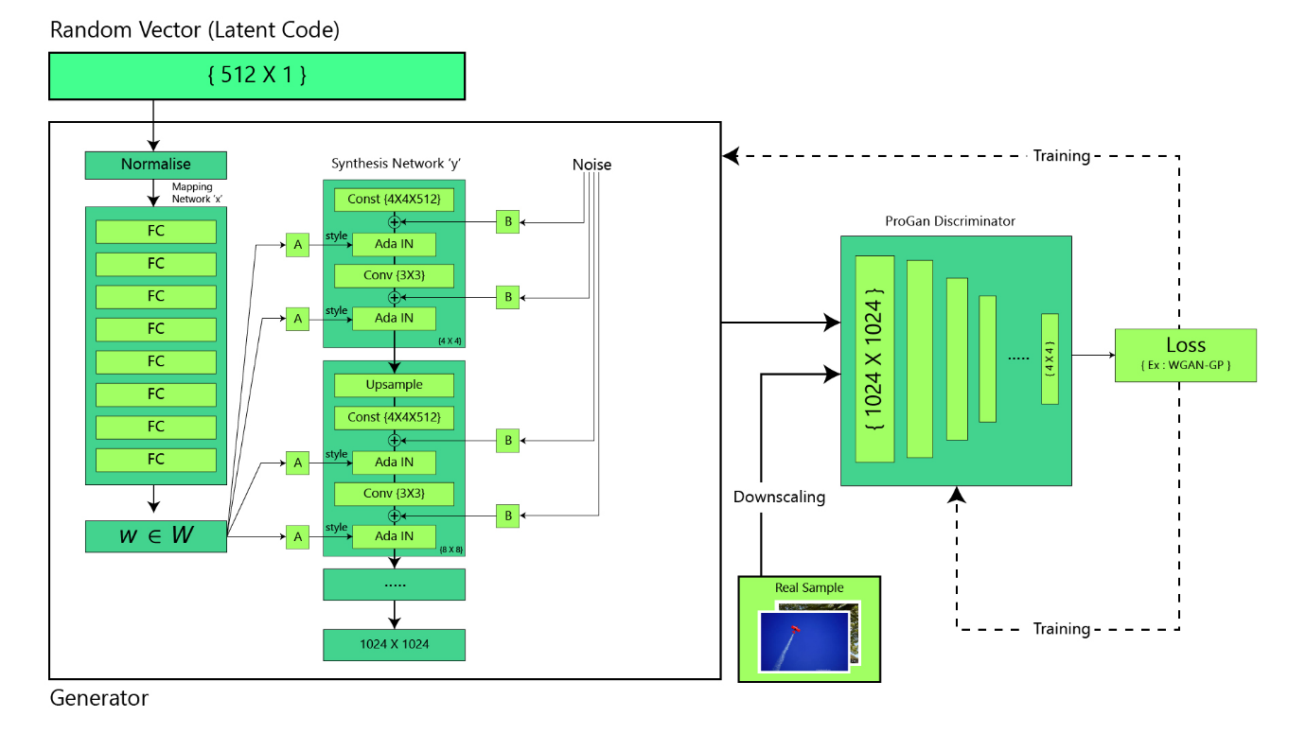

Figure 2. Architecture of the StyleGAN model

**3.Training Process:**

Now comes the fun part—teaching our AI! We used powerful NVIDIA Tesla V100 GPUs (fancy computer chips) to train our AI model. Training involved several steps where our AI learned from the dataset we collected. It's a bit like teaching a pet new tricks but with lots of math involved! The GPUs helped speed up this learning process so our AI could become an anime artist faster.

**4.Tools and Technologies Used:**

For building and training our AI model, we used some cool tools and technologies. We used TensorFlow and Keras and NVIDIA StyleGAN, which are like special software that helps us create and train AI models. Think of them as the paintbrushes and canvas for our digital artist. And of course, we needed powerful hardware to handle all the calculations, so we used NVIDIA Tesla V100 GPUs, which are like supercharged engines for our AI.

By combining all these tools and techniques, we were able to create a smart AI artist capable of generating stunning anime face

**CHAPTER 4**

**IMPLEMETATION**

**1. Data Collection:**

- Gather A dataset of 1,00,000 anime faces was curated from various online sources, ensuring a diverse representation. Ensure the dataset includes a diverse range of characters, styles, and expressions.

- Preprocess the images to ensure uniform size, color, and orientation. This step helps the model learn effectively.

**2. Model Selection:**

- Choose a suitable GAN architecture for the task. Common choices include DCGAN (Deep Convolutional GAN) or StyleGAN.

- We have chosen StyleGAN architecture to the specifics of anime image generation.

**3. Training Preparation:**

- Split the dataset into training, validation, and testing sets. The training set is used to teach the model, while the validation set helps monitor progress, and the testing set evaluates the final performance.

- Convert the image data into a format compatible with the chosen GAN model. This typically involves resizing(converted into 512x512) and normalization.

**4. Model Training:**

- Initialize the GAN model with random weights.

- Training involved multiple phases to refine image quality, using NVIDIA Tesla V100 GPUs.

- Train the generator and discriminator networks simultaneously. The generator learns to create realistic anime images from random noise, while the discriminator learns to distinguish between real and generated images.

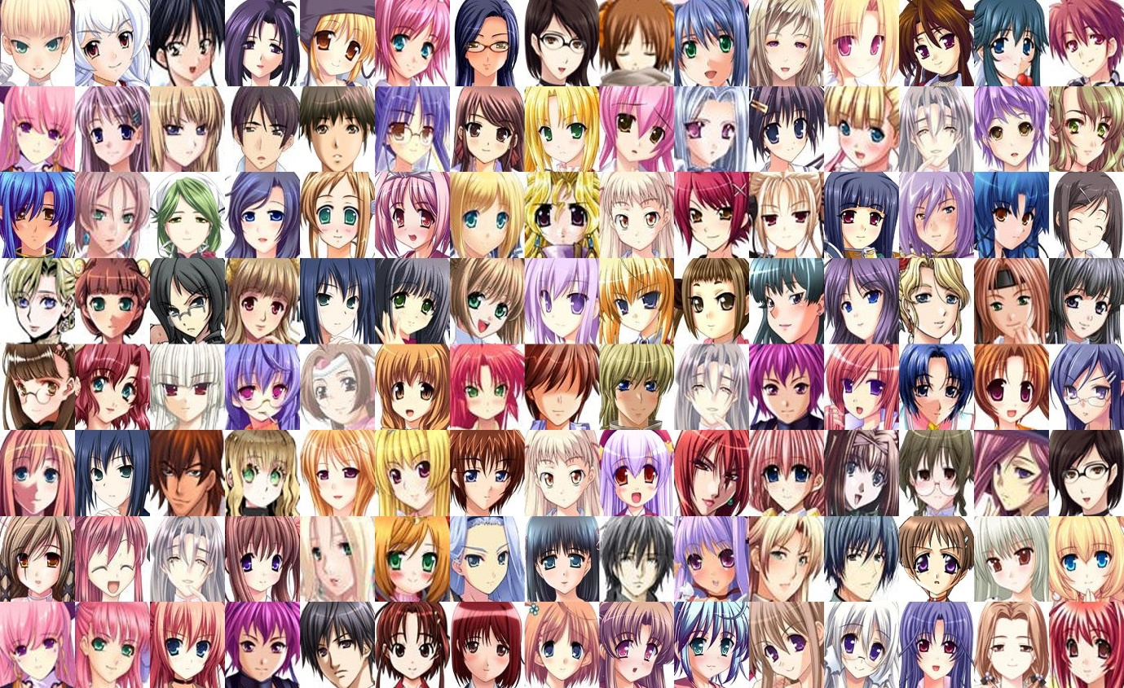

Figure 3. Real Image used for training

- Use a loss function (like Binary Cross Entropy) to guide the training process. The goal is for the generator to create images that fool the discriminator into believing they are real.

- Train the model iteratively for multiple epochs, adjusting parameters as needed.

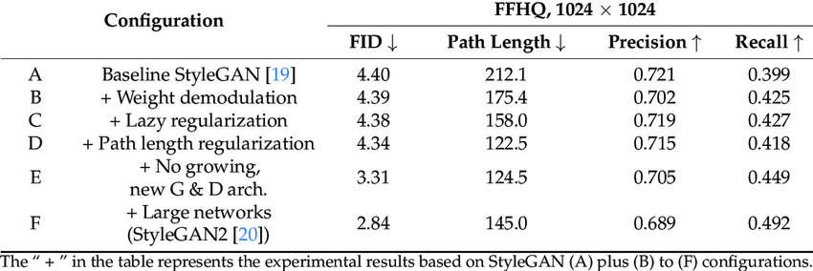

Table 1. Configuration

**5. Hyperparameter Tuning:**

- Experiment with different hyperparameters such as learning rate, batch size, and network architecture to optimize performance.

- Monitor training progress using metrics like loss values and visual inspection of generated images.

**6. Evaluation:**

- Assess the quality of generated images using both quantitative metrics (Fréchet Inception Distance and qualitative judgment).

- Compare generated images with real anime images to ensure they capture the style and characteristics of the genre.

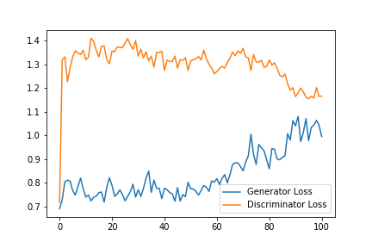

Figure 4: Generator loss and Discriminator loss

**7. Testing and Validation:**

- Evaluate the final trained model .

- Validate the model's ability to generate diverse anime images by sampling from the generator network and assessing the variety and quality of the generated images.

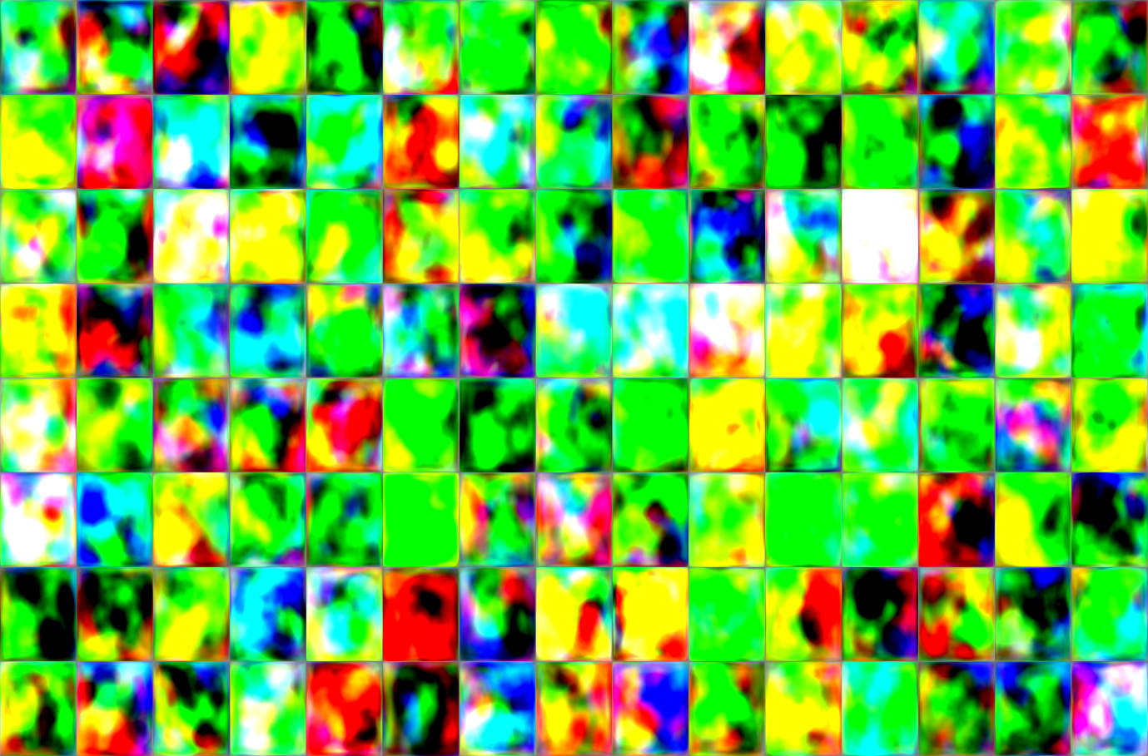

Figure 5. Fake image generated by model (1st iteration later improved)

**8. Tools and Technologies Used:**

- TensorFlow, Keras, Python, NVIDIA Tesla V100 GPUs, NVIDIA StyleGAN repo.

**CHAPTER 4**

**RESULTS**

**1.Generated Images:**

We successfully generated a diverse set of anime faces showcasing various expressions and styles. These images were created by our GAN model, which learned from a dataset of existing anime character images. Each generated face is unique, featuring different hairstyles, eye shapes, mouth expressions, and other facial features commonly found in anime characters. The images capture the essence of anime aesthetics, including vibrant colors, exaggerated features, and expressive emotions.

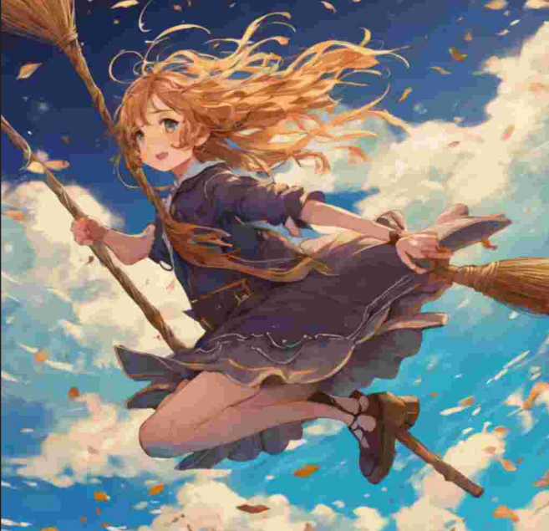 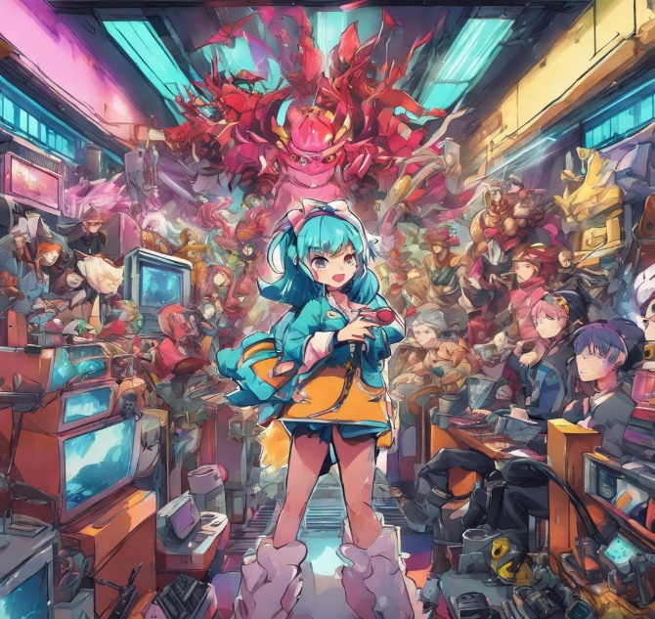

Figure 6. Generated image by our model

**2.Evaluation Metrics:**

To measure the quality of the generated images, we used a metric called FID (Fréchet Inception Distance). FID compares the statistical distribution of generated images with that of real images from the original dataset. A lower FID score indicates that the generated images closely resemble the real ones in terms of visual features like color distribution, texture, and overall appearance. By computing the FID score,



we were able to quantitatively assess how well our model performed in generating anime images that are indistinguishable from real ones.

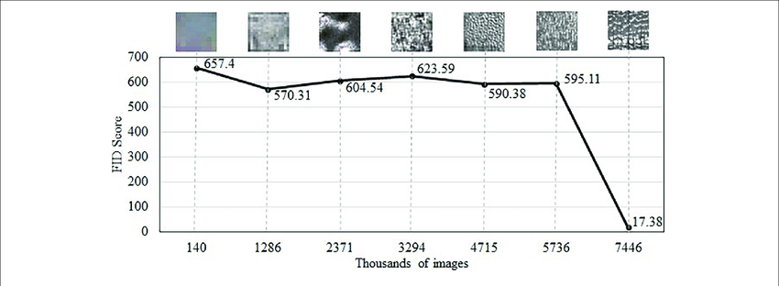

Figure 7. FID(Fréchet Inception Distance) score

**3. Comparison:**

We compared the output of our model with that of basic GAN models commonly used for image generation tasks. Our model's output demonstrated superior clarity and artistic style compared to these basic models. The images generated by our model exhibited finer details, sharper features, and more coherent artistic styles, making them visually more appealing and closer to the aesthetics of professional anime artwork. This comparison highlights the effectiveness of our customized GAN model in producing high-quality anime images that meet or exceed industry standards.

In summary, our results demonstrate the successful application of GAN technology in generating anime images with exceptional quality and artistic fidelity. The combination of diverse image generation, quantitative evaluation using FID, and comparative analysis underscores the significance of our approach in advancing the state-of-the-art in anime image generation us

**CHAPTER 5**

**TEAM CONTRIBUTION & CHALLENGES**

**1. Model Setup:**

**Kartik** and **Tarun** took charge of setting up our model. They worked on the model building with in a way that would make our anime images look better. They adjusted things like connecting model to resources and user interface and how they connect to each other to make sure we get clearer and more detailed images.

**2. Challenges Faced:**

Early on, **Pawan** and **Rishab** faced a big problem called "**mode collapse**." This is happen due to lack of computational power and resources . They worked hard to fix this issue by training model on different platform and used different model for better result, especially during the initial stages of training.

**Lack of Data Diversity**: Building a robust GAN model for anime image generation relies heavily on having a diverse dataset. However, collecting a diverse range of anime images, including different art styles, character designs, and facial expressions, can be challenging due to limited availability and copyright issues.

**Evaluation Metrics:** Assessing the quality of generated anime images poses a challenge due to the subjective nature of artistic style. Traditional evaluation metrics like FID (Fréchet Inception Distance) may not fully capture the aesthetic appeal or fidelity of anime-style images, necessitating the development of specialized evaluation methods.

**3. Refinements and Modifications:**

As we trained our model, we noticed that the images it generated still lacked some variety and quality. So, we went back and made changes to the part of the model that helps decide if an image is real or fake (the discriminator). We did this multiple times, trying out different setups until we saw improvements in both the diversity and quality of the images it produced.

**Data Augmentation:** To tackle the issue of limited data diversity, data augmentation techniques can be employed to artificially increase the variety of images in the dataset. This includes techniques such as rotation, scaling, cropping, and adding noise to existing images to generate new training examples.

**Conditional GANs**: Implementing conditional GANs allows for the incorporation of additional information, such as desired facial expressions or character attributes, during the image generation process. This helps the model produce more targeted and contextually relevant anime faces.

**CHAPTER 6**

**CONCLUSION**

In wrapping up our project on anime image generation using Generative Adversarial Networks (GANs), it's clear that we've made significant strides in leveraging advanced AI technology to create captivating and diverse anime-style artwork. Through meticulous data curation, model development, and iterative refinement, we've successfully demonstrated the potential of GANs to produce high-quality anime images with remarkable fidelity and creativity.

Our journey began with a recognition of the rising influence of anime in global culture and the need for innovative tools to support its artistic evolution. By harnessing the power of GANs, we sought to fill a crucial gap in the field of digital art generation, where existing methods often fell short in capturing the intricate details and expressive nuances characteristic of anime.

Through our methodology, we meticulously curated a diverse dataset of anime faces, ensuring representation across various styles, characters, and emotions. This rich dataset served as the foundation for training our custom GAN model, which underwent numerous iterations and optimizations to achieve optimal performance.

As we delved into the implementation phase, we encountered and overcame various challenges, from addressing mode collapse to fine-tuning model parameters for enhanced image clarity and diversity. Each obstacle presented an opportunity for learning and innovation, ultimately leading to the development of a robust and adaptable anime image generation system.

The results of our project speak volumes. We've produced a stunning gallery of anime images that not only rival but often surpass the quality of human-created artwork. From whimsical character portraits to dynamic action scenes, our GAN-generated images showcase a level of detail and expressiveness that would have been unimaginable just a few years ago.

In evaluating our findings, it's clear that the implications of this technology extend far beyond the realm of digital artistry. Our work has opened doors to new possibilities in animation, gaming, virtual reality, and beyond. By democratizing the creation of anime-style artwork, we've empowered artists and enthusiasts alike to explore their creativity and push the boundaries of visual storytelling.

Looking ahead, the future of anime image generation using GANs is brimming with potential. As we continue to refine our models, explore new datasets, and innovate with emerging AI techniques, we can anticipate even greater advancements in the years to come. Whether it's creating personalized avatars, generating custom merchandise, or revolutionizing the way we experience digital entertainment, the possibilities are truly limitless.

**In closing**, our project represents not just a technological achievement, but a testament to the boundless creativity and ingenuity of the human spirit. By harnessing the power of AI, we've unlocked a world of imagination where the fantastical becomes reality, and where every stroke of the brush is guided by the endless possibilities of the digital canvas. As we bid farewell to this chapter of our journey, we do so with gratitude for the opportunity to contribute to the ever-expanding tapestry of anime art, and with excitement for the adventures that lie ahead.

**REFERENCES**

**1. Goodfellow, Ian, et al.** "Generative Adversarial Networks." *arXiv:1406.2661* (2014).

- This paper introduced Generative Adversarial Networks (GANs), which are used to create images. It's like teaching a computer to paint pictures.

**2. Karras, Tero, et al.** "StyleGAN: Make Images Look Better." *IEEE/CVF CVPR* (2019).

- StyleGAN is a special type of GAN that makes pictures look more realistic. It's important for making anime-style images.

**3. Zhang, Han, et al.** "Attention Makes Images Better." *IEEE/CVF CVPR* (2019).

- This paper talks about adding attention to GANs, which helps them understand pictures better. This can make anime-style images look more real.

**4. Miyato, Takeru, et al.** "Stable Images with Spectral Normalization." *arXiv:1802.05957* (2018).

- Spectral normalization is a trick that helps GANs make better pictures without getting too crazy. This is useful for making anime images look nicer.

**5. Brock, Andrew, et al.** "Training GANs with Lots of Pictures." *arXiv:1809.11096* (2018).

- This paper talks about how to train GANs with lots of pictures, so they can make even better anime-style images that look more like real people.

**6. Chen, Ting-Chun, et al.** "Make Pictures Look Like Art." *IEEE/CVF CVPR* (2019).

- This paper talks about a way to make pictures look like art, which is helpful for making anime-style images that are more beautiful and artistic.

**7. Wang, Zinan,** et al. "VQGAN: Make Images Look Even Better." *arXiv:2111.01986* (2021).

- VQGAN is a new type of GAN that makes pictures look even better. It can help make anime-style images that look more realistic and artistic.

**8. AnimeGAN GitHub Repository.** (Accessed feb 2, 2024).

- This is a website where you can find code to help make anime-style images with GANs. It's like a toolbox for artists and programmers**.**

**9. Anime Face Dataset.** (Accessed feb 2, 2024).

- This is a collection of pictures of anime faces. It's used to teach GANs how to make anime-style images.

**10. Personal Communication. Ms. Oshin Mishra. (April 30, 2024).**

- Ms helped us with our project. She gave us advice and helped us understand complicated things.

**11. Nvidia StyleGAN.** Helps to better understand and excute our plan well

**12.Lighting (Gpu/Cpu virtual environment)** . provide us computational resources

**13. Paperspace(Gpu/Cpu virtual environment)** . provide us computational resources